Means-Ends Analysis in Artificial Intelligence

* We have studied the strategies which can reason either in forward or backward, but a mixture of the two directions is appropriate for solving a complex and large problem. Such a mixed strategy, make it possible that first to solve the major part of a problem and then go back and solve the small problems arise during combining the big parts of the problem. Such a technique is called **Means-Ends Analysis**.
* Means-Ends Analysis is problem-solving techniques used in Artificial intelligence for limiting search in AI programs.
* It is a mixture of Backward and forward search technique.
* The MEA technique was first introduced in 1961 by Allen Newell, and Herbert A. Simon in their problem-solving computer program, which was named as General Problem Solver (GPS).
* The MEA analysis process centered on the evaluation of the difference between the current state and goal state.

How means-ends analysis Works:

The means-ends analysis process can be applied recursively for a problem. It is a strategy to control search in problem-solving. Following are the main Steps which describes the working of MEA technique for solving a problem.

1. First, evaluate the difference between Initial State and final State.
2. Select the various operators which can be applied for each difference.
3. Apply the operator at each difference, which reduces the difference between the current state and goal state.

Operator Subgoaling

In the MEA process, we detect the differences between the current state and goal state. Once these differences occur, then we can apply an operator to reduce the differences. But sometimes it is possible that an operator cannot be applied to the current state. So we create the subproblem of the current state, in which operator can be applied, such type of backward chaining in which operators are selected, and then sub goals are set up to establish the preconditions of the operator is called **Operator Subgoaling**.

Algorithm for Means-Ends Analysis:

Let's we take Current state as CURRENT and Goal State as GOAL, then following are the steps for the MEA algorithm.

* **Step 1:** Compare CURRENT to GOAL, if there are no differences between both then return Success and Exit.
* **Step 2:** Else, select the most significant difference and reduce it by doing the following steps until the success or failure occurs.
  1. Select a new operator O which is applicable for the current difference, and if there is no such operator, then signal failure.
  2. Attempt to apply operator O to CURRENT. Make a description of two states.  
     i) O-Start, a state in which O?s preconditions are satisfied.  
     ii) O-Result, the state that would result if O were applied In O-start.
  3. If  
     **(First-Part <------ MEA (CURRENT, O-START)**  
     And  
     **(LAST-Part <----- MEA (O-Result, GOAL)**, are successful, then signal Success and return the result of combining FIRST-PART, O, and LAST-PART.

The above-discussed algorithm is more suitable for a simple problem and not adequate for solving complex problems.

Example of Mean-Ends Analysis:

Let's take an example where we know the initial state and goal state as given below. In this problem, we need to get the goal state by finding differences between the initial state and goal state and applying operators.

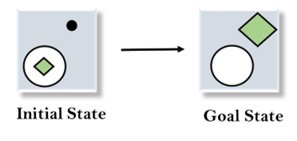

Solution:

To solve the above problem, we will first find the differences between initial states and goal states, and for each difference, we will generate a new state and will apply the operators. The operators we have for this problem are:

* **Move**
* **Delete**
* **Expand**

**1. Evaluating the initial state:** In the first step, we will evaluate the initial state and will compare the initial and Goal state to find the differences between both states.



**2. Applying Delete operator:** As we can check the first difference is that in goal state there is no dot symbol which is present in the initial state, so, first we will apply the **Delete operator** to remove this dot.

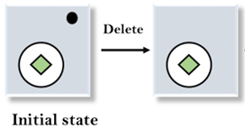

**3. Applying Move Operator:** After applying the Delete operator, the new state occurs which we will again compare with goal state. After comparing these states, there is another difference that is the square is outside the circle, so, we will apply the **Move Operator**.

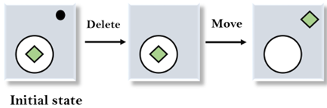

**4. Applying Expand Operator:** Now a new state is generated in the third step, and we will compare this state with the goal state. After comparing the states there is still one difference which is the size of the square, so, we will apply **Expand operator**, and finally, it will generate the goal state.

